**Transaction Processing System**

**Instruction Manual**

**By: Nushura Islam**

**System Documentation**

This instruction manual contains information regarding the database setup of the EFL application, CRUD functionalities of the application, known system issues and future scope of improvements.

**Database Setup**

The database mainly contains four tables which are staff, library user, book, and loan.

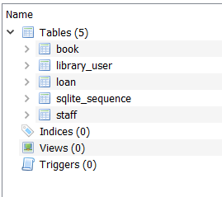

The staff table holds record of all staff members who worked and is working at the EFL library. Library user table stores all the info regarding members of EFL who borrowed books and thus, has membership to EFL. In addition, it also stores staff id which will assist in determining who registered the member. The book table also contains the staff id for the same purpose, and it contains all the information regarding the book as well. Lastly, the loan table record information regarding both the member and user info as well as the loan information. Hence, resulting in all the tables to be interconnected.

Here is an instance of the staff table in the database with two records inserted. All the other tables are similar in terms of how they look. Different tables can be selected by choosing the drop down box where the label says “Table”, located at the top left corner of the screen shot below.

**CRUD Functions**

CRUD refers to create, read, update and delete. These functionalities are implemented within the EFL application. The CRUD functionality implemented for the staff class is described below with he help of screen shots.

**Step 1:** Open/select the table or entity

**Step 2:** Click the ‘LOAD’ button to view the pre-existing list of staff ID. The ID’s present will then appear in the white box, under the title calls ‘Staff IDs’ .

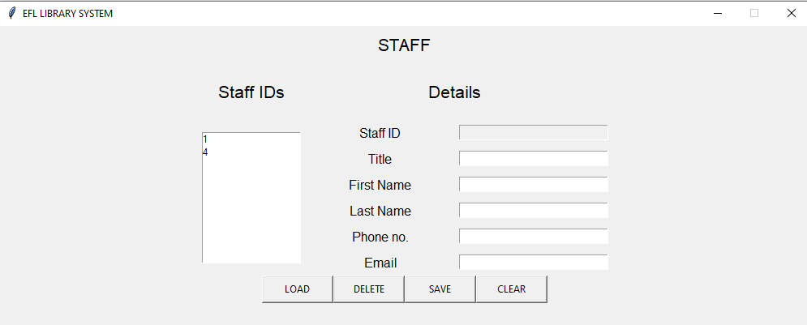

**Step 3 (Create and READ of CRUD):** To add a new staff into the system, fill up the form under the title called ‘Details’. Then click on the ‘SAVE’ button, followed by the ‘LOAD’ button to view the newly added staff. Graphical user interface, application

NOTE: Staff ID is auto generated by the application.

**Step 4(Update of CRUD):** To update a staff info. Select a staff id from the ID list followed by the update. Then make sure to click on the ‘SAVE’ button to successfully save it into the database. The screen shot bellow, has the record of the staff who was inserted in the earlier step. His first name was spelt wrong, so it has been updated, from Jay to Jaden.

After the ‘Save’ button has been clicked a success message will pop up.

**Step 5(Delete of CRUD):** To delete a record, simply select the staff ID from the list and press the ‘DELETE’ button. This will be followed by a success message.

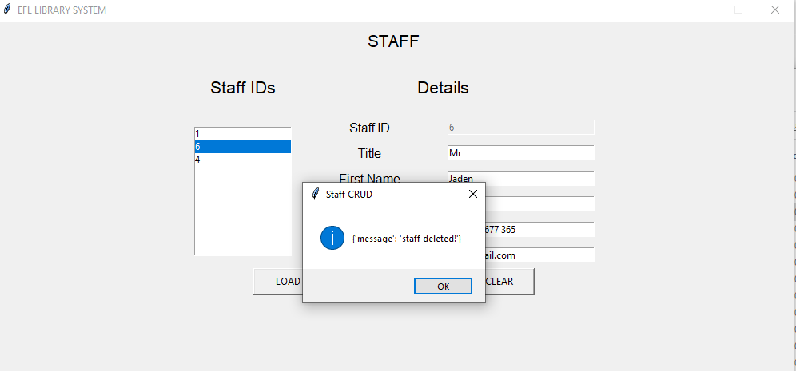

**CLEAR button:** The clear button is present so that if all the fields within a certain form needs to be deleted then it can be done with a single click.

NOTE: Other forms has similar functionality.

**System Issues and Future Improvements**

The system can carry out the CRUD functionalities successfully. However, the form fields cannot connect to the fields of other tables yet. For example, it would be better for the library user form to automatically detect the staff id who registered the user. If that occurred then staff would not require to enter their ID manually and thus, would reduce the chance of human error. Hence, that is a scope that can be worked towards for improvement.